Software Design
Specification
for
Police Administration
System
Version 1.0
Prepared by Abhirup Mukherjee 13BCE0076
Anirudh Dahiya 13BCE0606
Arman Mann 13BCE0073
CSE 325
Guided by Prof Sureshkumar N L35 + L36
Table of Contents
- Introduction………………………………………………………………….1
  - Purpose…………………….……………………………………………..1
  - Scope……………………….…………………………………………….1
  - Definitions, Acronyms, Abbreviations…………………………………..1
  - Project Deliverables……………………………………………………...2
  - Software Model…………………………………………………………..2
  - Roles and Responsibilities……………………………………………….3
  - References………………………………………………………………..3
  - Overview………………………………………………………………....3
- Overall Description…………………………………………………………..4
  - Product perspective……………………………………………………....4
  - Product functions………………………………………………………...4
  - User characteristics……………………………………………………....5
  - Constraints……………………………………………………………….5
  - Assumptions and dependencies………………………………………….5
- External Interface Requirements.…………………………………………….6
- System Architecture………………………………………………………….9
4.1 Chosen System Architecture….…………...……………………………..9
4.2 Discussion of Alternative Designs…………………………………….....9
4.3 Component Design…………………………...…………………………..9
4.4 Class Diagrams………………………………..………………………...10
4.5 Sequence Diagram……………………………..………………………..11
4.6 Activity Diagram……………………………………..…………………12
4.7 Data Flow Diagram……………………………..…...………………….13
4.8 State Diagram…………………………….……………………………..14
4.9 Gantt Chart……………………………….……………………………..14
5. Detailed Module Description………………….……………………………15
5.1 Registration Module……………………………………………………...15
5.2 Login Module…………………………………………………………… 15
5.3 Traffic Fine Registration Module………………………………………...15
5.4 Traffic Fine Payment Module…………………………………………….15
5.5 FIR Registration Module ………………………………………………...15
5.6 Criminal List Module……………………………………………………..15
5.7 Message Broadcasting Module…………………………………………...15
5.8 Passport Verification Module…………………………………………….16
6. Deliverables…………………………………………………………………...17
7. User Interface Screenshots……………………………………………………21

Introduction

Purpose
This SRS describes the requirements and specification of the Police Administration System. It explains the functional features of the system along with interface details, design constraints and related considerations such as performance characteristics. The SRS is intended for Police use only. Segregation has been made via login with respect to Head Office Police and Regional Police.

Scope
The Police Administration System is meant to be a web application maintained by police stations across a region. There are two basic users-Police officers in local police stations and Police Officers in the Head Office. The Police Administration System will provide functionalities like Passport Verification, Traffic Fine Registration and Payment, displaying Criminal List, FIR Registration and Message Broadcasting. Head Office police officers can update the criminal database and acts as the final authority in sending a passport application to the Passport Office. The Police Administration System does away with the model of written records and files as everything is computerized. Registers of FIR complaints as well as documents for passport verification need not be maintained anymore as everything is now done via a database maintained on a server. The Police Administration System serves the objective of being efficient and reliable (in terms of fine collection and storing data).

Definitions, Acronyms, Abbreviations

PAS
Police Administration System – Web Application used by police stations to take care of daily tasks.

1.3.2 PD

Police Department – Has restricted access to the system. Can only view wanted list. Not update.

1.2.3 HO

Head Office – User with highest access credentials.

1.3.4 Bootstrap

Bootstrap is a free and open-source front-end library for creating websites and web applications. It contains HTML- and CSS-based design templates for typography, forms, buttons, navigation and other interface components, as well as optional JavaScript extensions. It aims to ease the development of dynamic websites and web applications.

1.3.5 HTML5

HyperText Markup Language – It will be used to create web pages

1.3.6 CSS

Cascading Style Sheets – It will be used to style web pages

1.3.7 UML

Unified Modelling Language-is a standard language for writing software blueprints. The UML may be used to visualize, specify, construct and document

1.3.8 HTTP

Hypertext Transfer Protocol-It’s a service protocol

1.3.9 Django

Django is a free and open-source web framework, written in Python, which follows the model–view–controller (MVC) architectural pattern.

Project Deliverables
- The documentation phase will deliver a Software Design Specification and a Software Requirements Specification.
- Creation of basic Police Administration System with functionalities of FIR Registration, Criminal Record and Passport Verification.
- Final Product with advanced functionalities delivered.

Software Process Model
The process model we will be implementing is Incremental Model. This is a method of software development where the product is designed, implemented and tested incrementally (a little more is added each time) until the product is finished. It involves both development and maintenance. The product is defined as finished when it satisfies all of its requirements. This model combines the elements of the waterfall model with the iterative philosophy of prototyping.

The incremental model allows to add functionalities to the project via Increments. It allows us to get a working model quickly and then evolve the model by adding increments.
After each iteration, testing is conducted. During this testing, faulty elements of the software can be quickly identified. Customer can respond to features and review the product for any needful changes.

Roles and Responsibilities

Project Coordinator
Roles:
- Responsible for maintenance of the project plan, maintenance.
- Provides administrative support to the team.

Responsibilities:
- Establishes standards, tools and procedures in the project including issue, risk, change and information management.
- Reviews project activities for compliance with procedures and standards.
- Assist with the production of user documentation.

Project Team Member
Roles:
- The staff who actively work on the project, at some stage, during the lifetime of the project.

Responsibilities:
- Provide functional expertise in different fields.
- Work with users to ensure that project meets user needs.
- Documentation and analysis of the current and future processes and systems.
- Identification and mapping of information needs.
- Defining requirements for reporting and interfacing.

References
- Software Engineering, Seventh Edition, Ian Sommerville.
- SWEBOK V3.0, Guide to Software Engineering Body of Knowledge
- Wikipedia: http://en.wikipedia.org

Overview
The rest of the SRS examines the specifications of the Police Administration System in detail. Section 2 of the SRS represents the general factors that affect the Police Administration System and its requirements such as user characteristics and project constraints. Section 3 outlines the detailed, specific, functional, performance, system and other related requirements of the Police Administration System.

Overall Description

Product Perspective

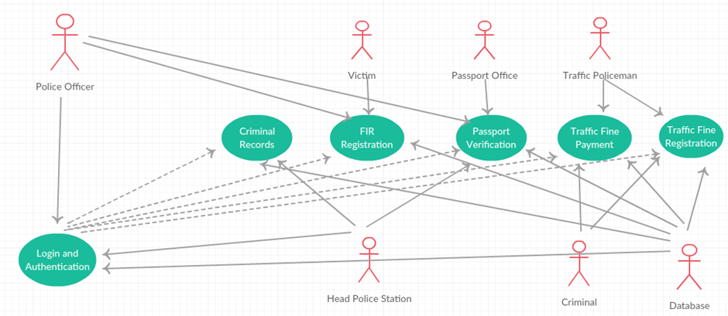

USE CASE | DESCRIPTION
Login and authentication | Authentication process for both head office and police departments
Criminal records | Database records which can be updated by head office and can be viewed by police officers
FIR Registration | FIR registrations can be updated and added by police stations.
Passport Verification | Passport can be verified by police officers.
Traffic receipt generation | Traffic receipt can be generated by traffic police
Cancel Registration | The registered users can apply for cancellation of their registration at any point of time.

Product Functions
- Online payment of fine.
- Online registration of FIR.
- Passport verification with a two tier confirmation system.
- Viewing and updating of a Criminal Database.
- Communication between various police departments.

User Characteristics
There are essentially two classes of users for the Police Administration System- Police Officers of the local police station and Police Officers of the Head Office. Both users must have basic knowledge of operating a computer system i.e. proficient in using a keyboard and a mouse. The user needs to know the exact nature of the submitted job as most of the functionalities are of high importance such as FIR Registration and Passport Verification.

Constraints
- GUI is only in English.
- All police stations require internet access.
- This system is working for single server.
- System is heavily dependent on internet service.
- Training of police required to use the system.

Assumptions and Dependencies
- All police stations have a computer system installed with net connectivity.
- Users of the system are well versed in operating a computer system.
- For the passport verification process, the passport application form has been already been submitted to the Passport Office.
- The receipt number for the payment of traffic fine should be present in the database.

External Interface Requirements
Software interfaces provide access to computer resources (such as memory, CPU, storage, etc.) of the underlying computer system.

- Client on Internet - Web Browser, Operating System (any)
- Web Server - Apache, Operating System (any)
- Data Base Server - MySQL, Operating System (any)
- Development End - Web Designing Tools (Django, Bootstrap, Java, JavaScript, HTML, CSS, XML, AJAX, MySQL), OS (Windows)

Hardware interfaces exist in many of the components in the various I/O devices etc. The various hardware interfaces required are:

- Processor
- RAM
- Memory Usage
- CPU Usage

Minimum requirements:

 |  | CLIENT SIDE
 | Processor |  | RAM | Disk Space
Internet Explorer-6 | Intel Pentium III or AMD  800 MHz |  | 128 MB | 100 MB

Table 2.2(a) Client side minimum requirements

 |  | SERVER SIDE
 | Processor | RAM | Disk Space
Web Designing Tools | Intel Pentium III or AMD  800 MHz | 1 GB | 3.5 GB
MySQL | Intel Pentium III or AMD  800 MHz | 256 MB | 500 MB(Excluding Data  Size)

Table 2.2(b) Server side minimum requirements

Recommended Requirements:

 |  | CLIENT SIDE
 | Processor | RAM | Disk Space
Internet Explorer-6 | All Intel or AMD - 1 GHZ | 256 MB | 100 MB

Table 2.2(b) Client side recommended requirements

 |  | SERVER SIDE
 | Processor | RAM | Disk Space
Web Designing Tools | All Intel or AMD - 2 GHZ | 2 GB | 3.5 GB
Internet Explorer-6 | All Intel or AMD - 2 GHZ | 512 MB | 500 MB(Excluding Data Size)

Table 2.2(c) Server side recommended requirements

System Architecture

Chosen System Architecture
Client Server model is the chosen system architecture. Interaction happens with the server based on client request. The server is accessed only when a function is performed.

Discussion of alternative designs
Client Server was chosen as it best fits the functionality provided by the application. Pipes and Filters was not a viable option as there is no sequential dependency involved where output of one step can be input for another step.

Component Design

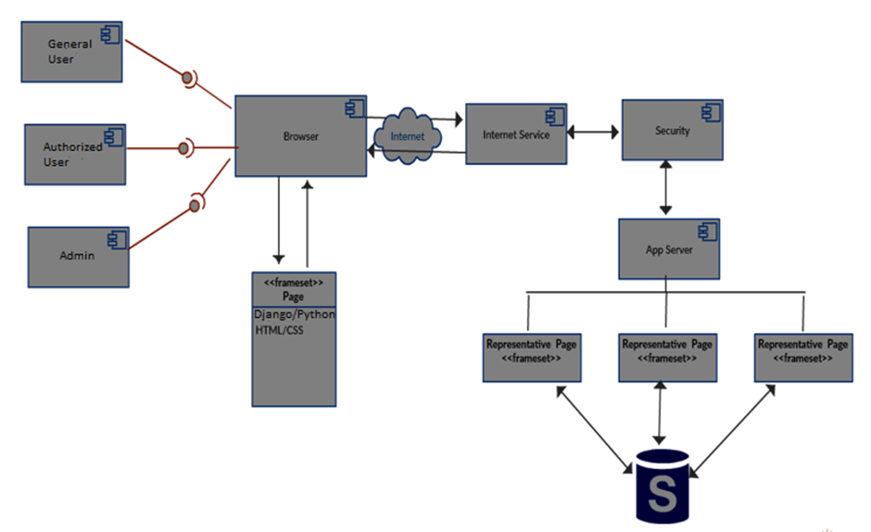

Class Diagram

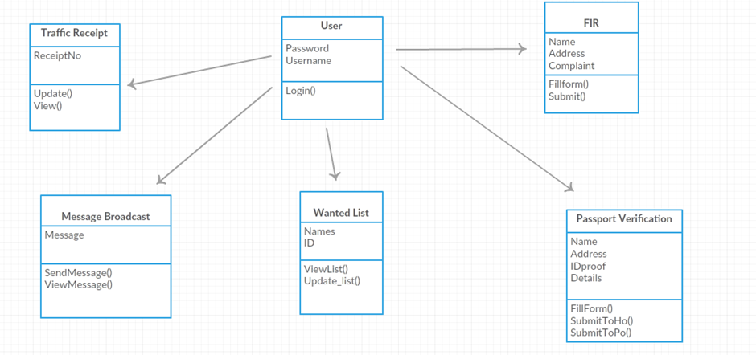

Sequence Diagram

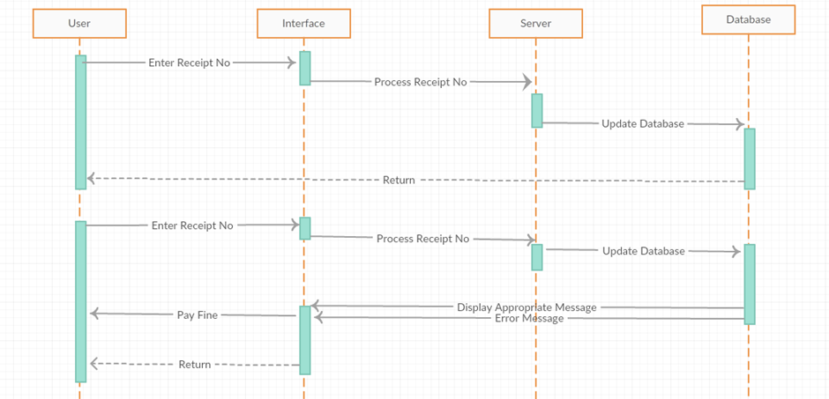

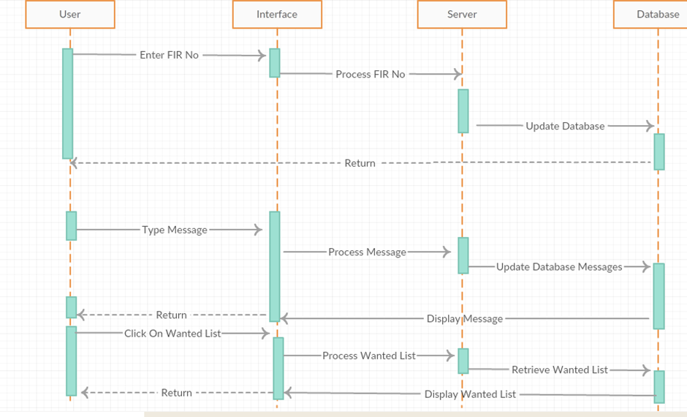

Activity Diagram

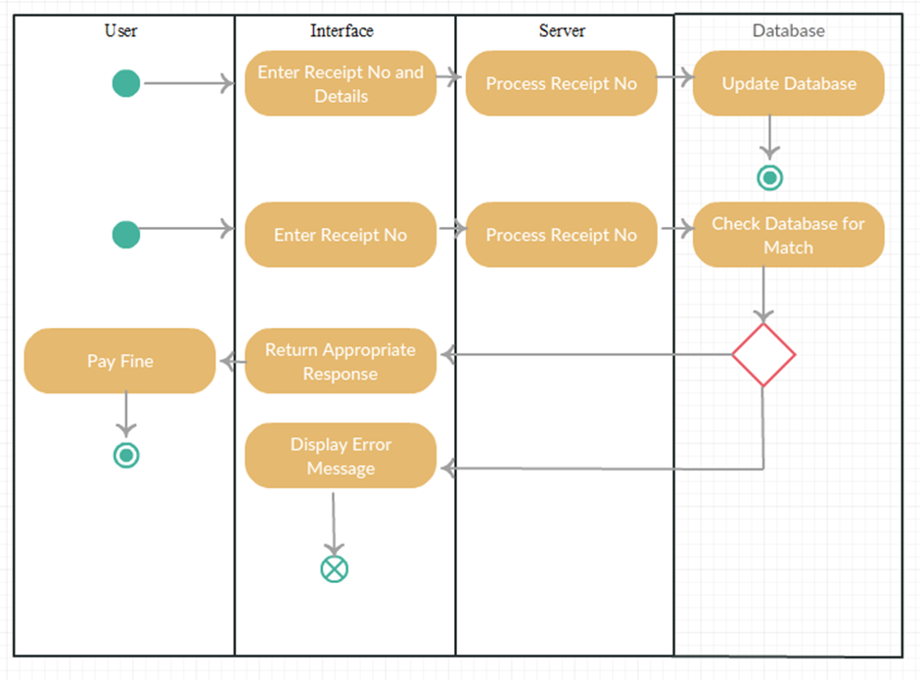

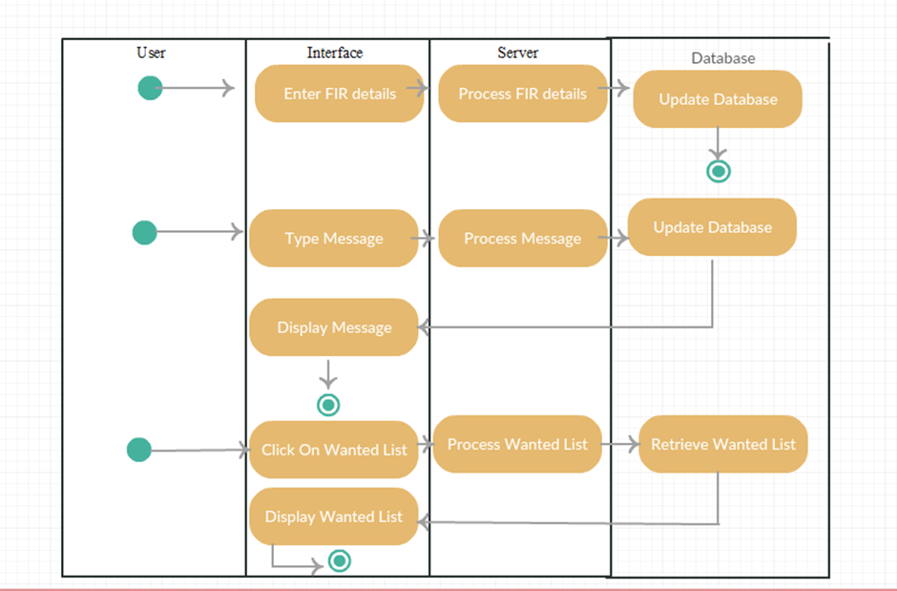

Data Flow Diagram

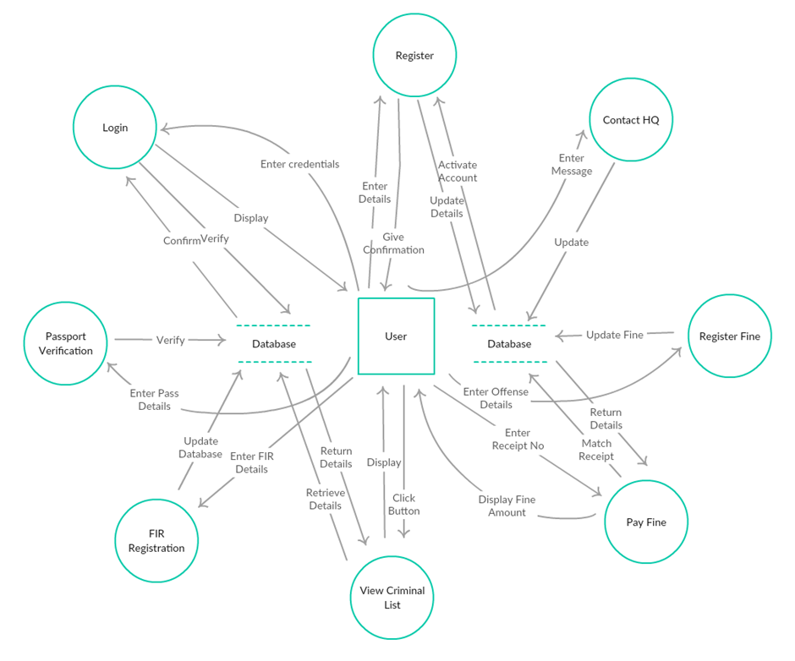

State Diagram

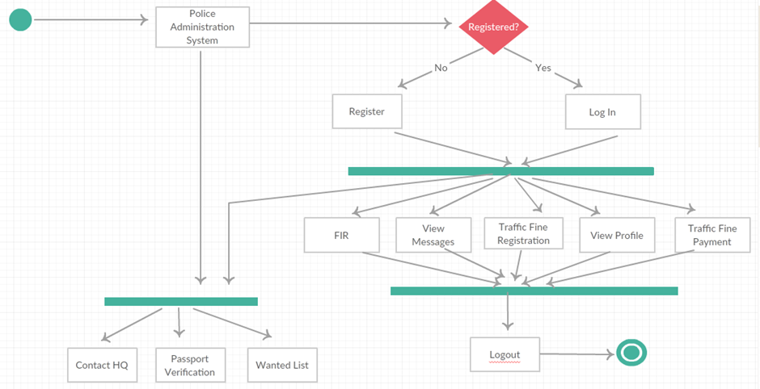

Gantt Chart

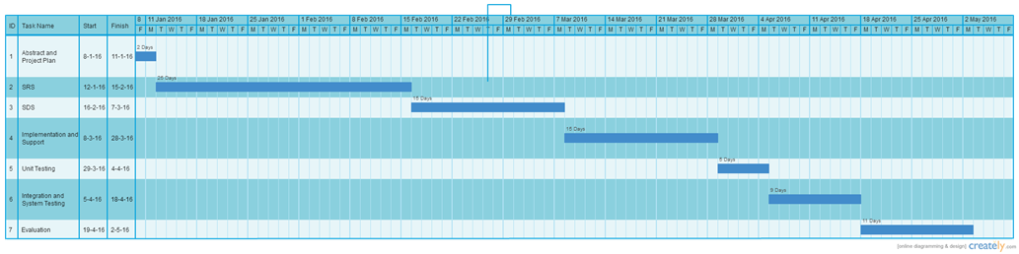

Detailed Module Description

Registration Module:
This module allows police officers to register/sign up to use the police administration system using their credentials. The officers can only use their accounts after approval from a head office administrator.

Login Module:
This module allows user to login to the police administration system to use the features exclusively available to registered officers.

Traffic Fine Registration Module:
This module allows police officers to register traffic offenders. A form asks for a randomly generated receipt number, the name of the offender, the details of the crime committed and the amount to be paid for the offense.

Traffic Fine Payment Module:
This module is to confirm payment of traffic fine payments. A form asks for the receipt number on the receipt issued to the violator. The database is searched for that particular receipt. If the status of the receipt is unpaid in the table, then the status is changed as payment has been received by the police officer at the desk. If the receipt doesn’t exist or a receipt number has been entered who’s status is already paid, appropriate message is displayed.

FIR Registration Module:
This module allows the lodging of an FIR complaint. A form takes in details from the victim such as name, address, criminal details and the form is submitted. There is also a facility for the police to view previously filed FIRs.

Criminal List Module:
This is a page which lists pictures and details of the wanted criminals. Local police stations can only view the list. Head office police station has credentials to update it. The initial page allows us to click on individual criminal pictures to get detailed view.

Message Broadcasting Module:
The message broadcasting module allows sending of messages to a common police administration system notice board wherein every other registered police officer is able to read the message broadcast.

Passport Verification Module:
This is a two tier confirmation module. The local police station has a police officer who fills in the confirmation form which includes checking for proper documents to confirm whether the applicant is a citizen of India. Once the form is submitted, a police officer in the head office checks the form one last time and then forwards it to the passport office.

Deliverables

Authentication Page

Description
A webpage that takes in username and password and checks whether the user is valid or not.

Deliverables and Milestones
Deliverables are a webpage for authentication and the redirected homepage.
Milestones would be creation of the database of users, creation of HTML form on client side to take in username and password and finally creation of the homepage to which authentication page redirects to.

Resources Needed
Internet Access, Bootstrap, Text Editor, Web Browser.

Dependencies and Constraints
The database is the first task to be considered. Without it we cannot verify the user. Following it the front end of the page should be made after which the back end is made which interacts with the database.
Constraints would involve unavailability of resources like internet connection.

FIR Registration Form

Description
A webpage showing a form is created. In the form, the user has to fill in the details about the crime.

Deliverables and Milestones
Deliverables are a webpage to fill the details which also provides a provision for viewing pending FIRs.
Milestones would be creation of the database of users, creation of HTML form on client side to take in username and password and finally creation of the homepage to which authentication page redirects to.

Resources Needed
Internet Access, Bootstrap, Text Editor, Web Browser.

Dependencies and Constraints
The database is the first task to be considered. Without it we cannot verify the user. Following it the front end of the page should be made after which the back end is made which interacts with the database.
Constraints would involve unavailability of resources like internet connection.

Passport Verification Form

Description
A webpage showing a form is created. In the form, the user has to fill in the details about proof of citizenship and so on.

Deliverables and Milestones
Deliverables are a webpage to fill the details which is sent to the HO on submitting.
Milestones would be creation of the database of users, creation of HTML form on client side to take in username and password and finally creation of the homepage to which authentication page redirects to.

Resources Needed
Internet Access, Bootstrap, Text Editor, Web Browser.

Dependencies and Constraints
The database is the first task to be considered. Without it we cannot verify the user. Following it the front end of the page should be made after which the back end is made which interacts with the database.
Constraints would involve unavailability of resources like internet connection.

Traffic Fine Registration Module

Description
A module which allows the input of details of traffic offenses into the database.

Deliverables and Milestones
Deliverables are a webpage which takes in a randomly generated receipt number, name of offender, offense committed and amount to be paid as an input and performs necessary operations on the database.
Milestones would be creation of the database of users, creation of HTML form on client side to take in username and password and finally creation of the homepage to which authentication page redirects to.

Resources Needed
Internet Access, Bootstrap, Text Editor, Web Browser.

Dependencies and Constraints
The database is the first task to be considered. Without it we cannot verify the user. Following it the front end of the page should be made after which the back end is made which interacts with the database.
Constraints would involve unavailability of resources like internet connection.

Traffic Fine Payment Module

Description
A module which updates the status of a receipt on receiving payment of fine.

Deliverables and Milestones
Deliverables are a webpage which takes in receipt number as an input and performs necessary operations on the database.
Milestones would be creation of the database of users, creation of HTML form on client side to take in username and password and finally creation of the homepage to which authentication page redirects to.

Resources Needed
Internet Access, Bootstrap, Text Editor, Web Browser.

Dependencies and Constraints
The database is the first task to be considered. Without it we cannot verify the user. Following it the front end of the page should be made after which the back end is made which interacts with the database.
Constraints would involve unavailability of resources like internet connection.

Criminal List

Description
A list which shows the top ten wanted criminals.

Deliverables and Milestones
Deliverables are a webpage which takes in receipt number as an input and performs necessary operations on the database.
Milestones would be creation of the database of users, creation of HTML form on client side to take in username and password and finally creation of the homepage to which authentication page redirects to.

Resources Needed
Internet Access, Bootstrap, Text Editor, Web Browser.

Dependencies and Constraints
The database is the first task to be considered. Without it we cannot verify the user. Following it the front end of the page should be made after which the back end is made which interacts with the database.
Constraints would involve unavailability of resources like internet connection.

User Interface Screenshots

Registration Page

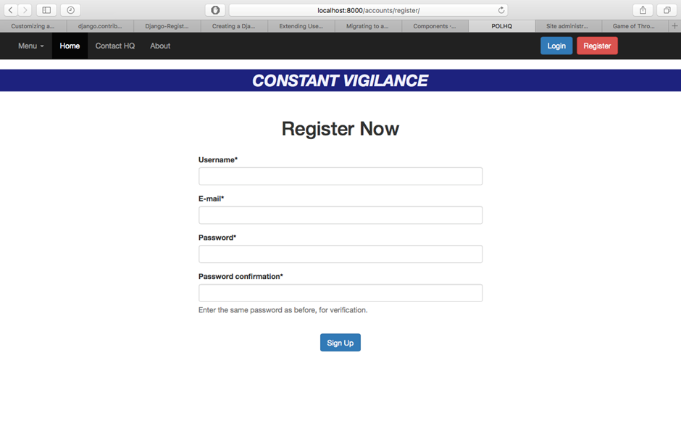

Login Page

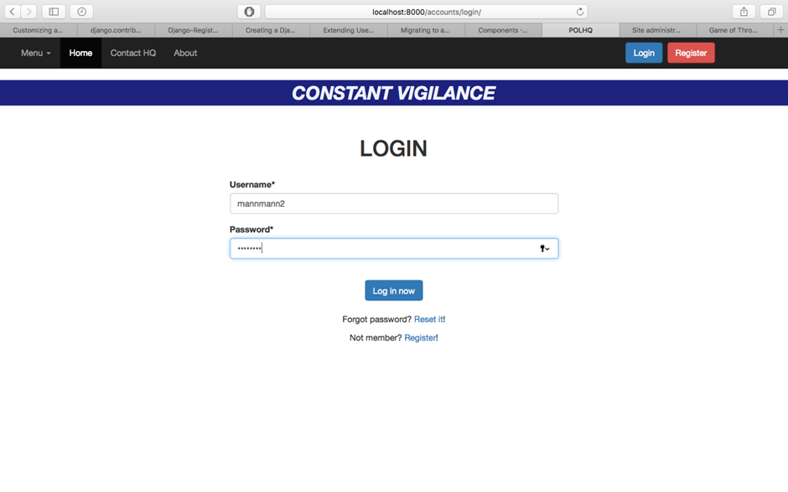

Home Page

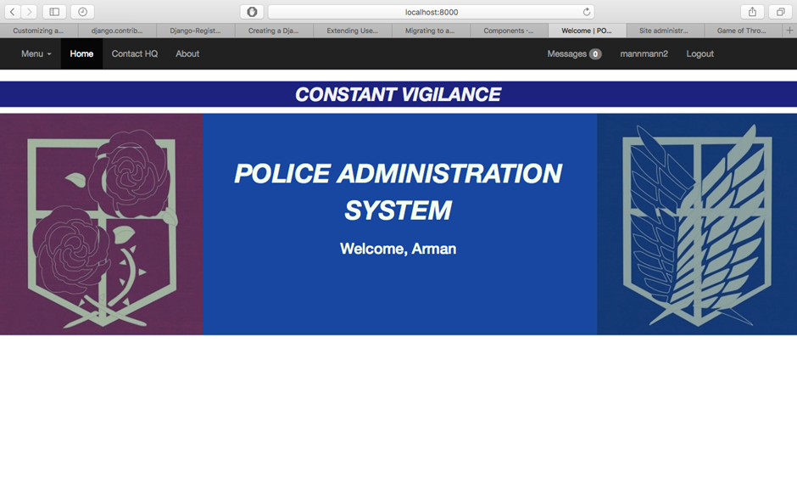

Message Broadcast Page

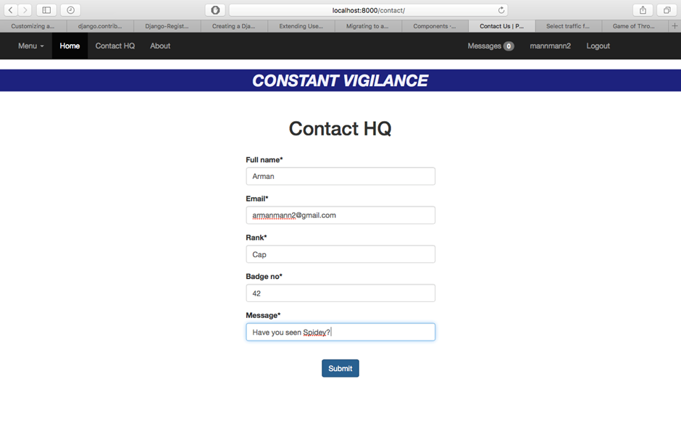

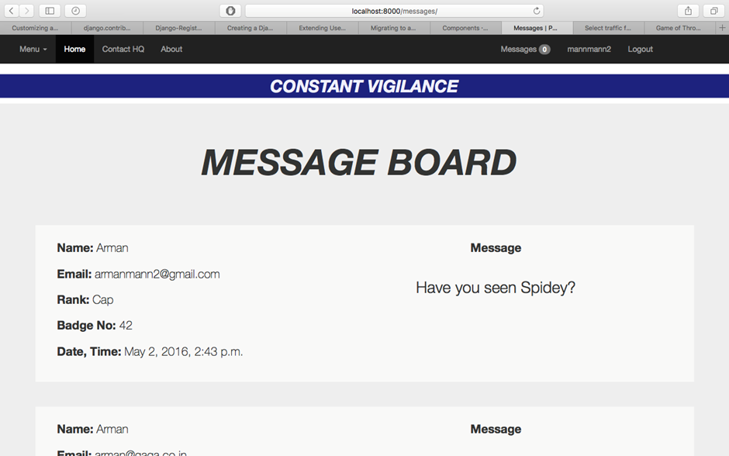

Profile Page

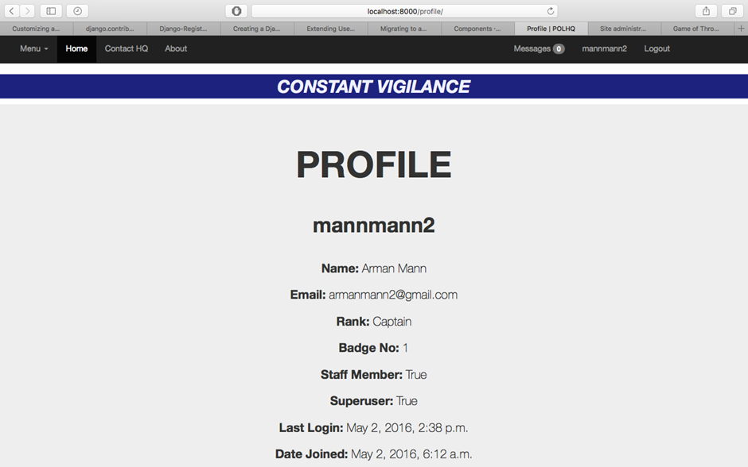

Fine Registration Page

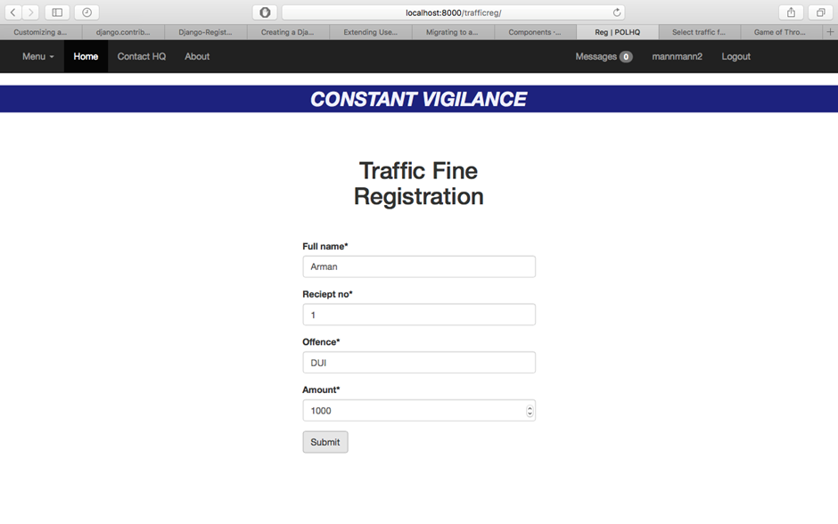

Fine Payment Page

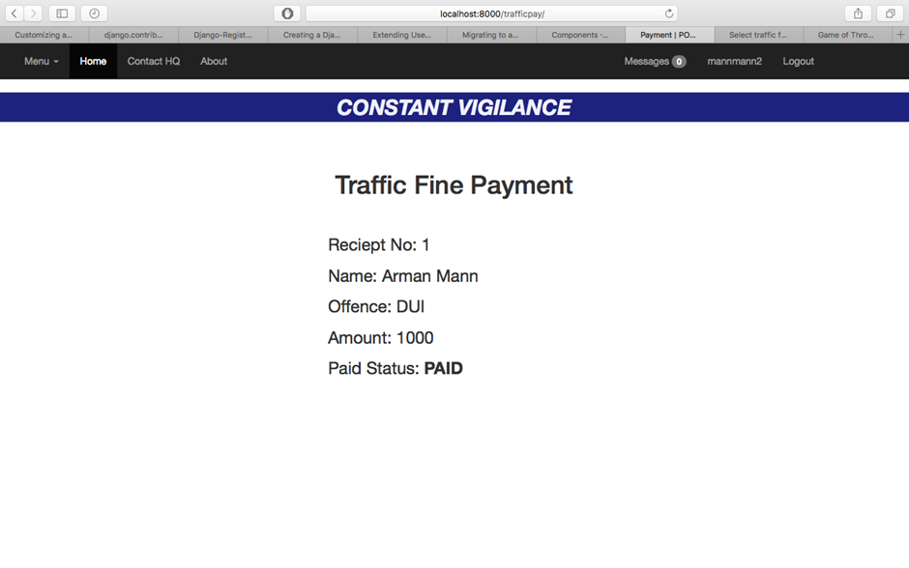

FIR Registration Page

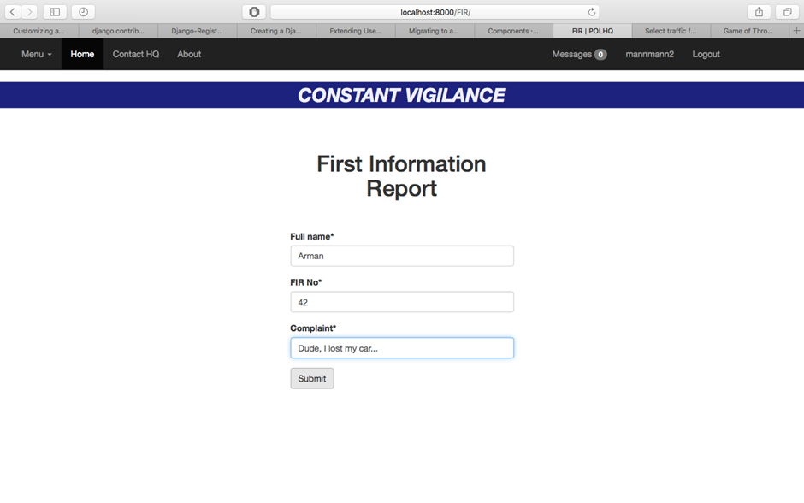

Criminal List

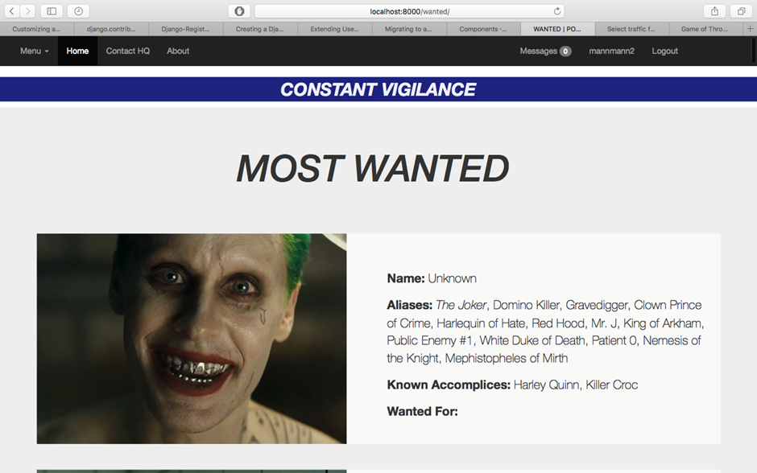

Passport Verification Page

